Since the last project checkpoint, we have modified our scope. In the original scope, we didn’t address the areas that we would focus on. We also had a somewhat poor choice of language, making our proposal seem rather indecisive and unsure of itself. So we went through the entire proposal, making changes to it in order to be more decisive and sure of ourselves. We also added more details about ClassHub and the areas we would be primarily focusing on. Doing this really helped us figure out exactly how the project will function and how it could help our users.

Since our last submitted document, we discussed needing a login feature for students and teachers. Students need to view their courses and teachers need to post announcements, course materials, etc. Another feature we discussed is a “Course Search” feature where students and teachers are able to search for courses and find detailed section information, similar to QUACS and ‘Class Search’ in SIS.

We divided tasks amongst ourselves, and have created a mockup of ClassHub on Canva to get an idea of what the application should really look like. We haven’t really begun working on the actual website and its pages until today, March 16th. We have started to work on the project and plan to meet at least once a week to discuss progress on the project, get help from each other, and work together to complete our project. We’ve begun on the landing page and will begin other pages within the next few days.

This is our Trello board in which we’ll use to keep track of the tasks that need to be done.

<https://trello.com/invite/b/M2rjJl7J/ATTI2cffc1f2f1501cdf748279591d3c2a5e9C467824/term-project>

Our current tasks include creating the landing page, course page, assignments page, adding style with CSS and interactivity with JavaScript, etc.

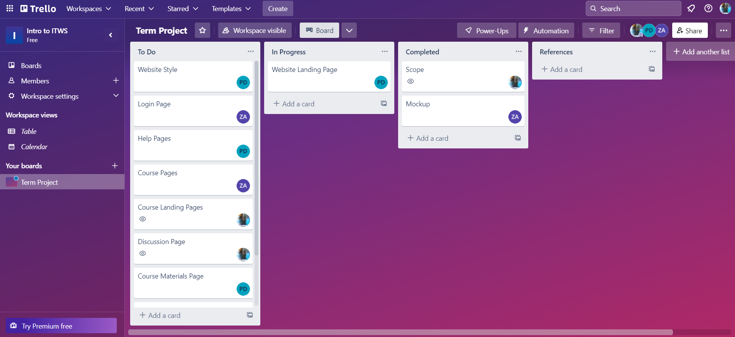

We updated the Information Architecture to include the docs folder in the root directory. This folder contains all of the various documents pertaining to ClassHub including our project plan, scope, and the mockups for each page. We also added a new HTML file for the login page, as well as a JS file for the login code that we’re likely to keep separate from the rest of our JS code for organization. The updated IA is below:

**Information Architecture (root = /)**

* /index.html → ClassHub’s home page
  + /login/
    - /login/login.html
  + /help/ → All help pages
    - /help/index.html → Help page
    - /help/page1.html → Pages to explain how to use the website
    - /help/page2.html
    - …
* /docs/ → All documents pertaining to ClassHub including the project plan and scope
  + /docs/scope.docx
  + /docs/mockups/ → All mockups
    - /docs/mockups/landing_page.png
  + …
* /scripts/ → All JS scripts
  + /scripts/login.js
  + /scripts/script1.js
  + …
* /styles/ → All CSS files
  + /styles/images/ → All images
    - /styles/images/image1.png
    - …
  + /styles/styles.css
  + …
* /courses/ → All courses stuff
  + /courses/index.html → Courses landing page (should show you all courses you’re registered for)
    - /courses/courseName1/ → specific courses
      * /courses/courseName1/index.html → Course home page
      * /courses/courseName1/announcements/
        + /courses/courseName1/announcements/announcement1
        + …
      * /courses/courseName1/materials/
        + /courses/courseName1/materials/mat1
        + …
      * /courses/courseName1/assignments/
        + /courses/courseName1/assignments/assig1
        + …
      * /courses/courseName1/discussion/
        + /courses/courseName1/discussion/hwHelp
        + …
    - /courses/courseName2/
    - …